KELOMPOK 1
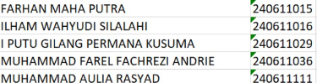
1. Setup dan Persiapan Proyek
Diasumsikan Anda sudah memiliki proyek CodeIgniter 4 yang terinstal.
1.1. Menjalankan Server Pengembangan
Di terminal proyek Anda, jalankan perintah ini untuk memulai server lokal:
php spark serve
Server biasanya akan berjalan di http://localhost:8080.
1.2. Konfigurasi Database
Pastikan file .env (atau app/Config/Database.php) Anda sudah dikonfigurasi.
database.default.hostname = localhost
database.default.database = nama_database_anda
database.default.username = root
database.default.password =
database.default.DBDriver = MySQLi
1.3. Langkah Database (Migration)
Jika Anda ingin membuat tabel menggunakan fitur Migration CodeIgniter, Anda akan menjalankan perintah berikut di terminal :
php spark make:migration AddTable1a1
php spark make:migration AddTable1a2
# ... dst
Lalu perintah untuk menjalankan semua file migration dan membuat tabel
php spark migrate

2. Kode Model (app/Models/)
Model berfungsi sebagai antarmuka tunggal untuk interaksi dengan tabel database.
2.1. DBtable1a1.php
PHP
<?php
namespace App\Models;

use CodeIgniter\Model;

class DBtable1a1 extends Model
{
protected $table = '1a1';
protected $primaryKey = 'id';
protected $useAutoIncrement = true;
protected $allowedFields = ['unit_kerja', 'nama_ketua', 'periode_jabatan', 'pendidikan_terakhir', 'jabatan_fungsional', 'tupoksi'];

public function cariData($cariData = null)
{
$builder = $this->db->table($this->table);
if (!empty($cariData)) {
$builder->like('unit_kerja', $cariData);
$builder->orLike('nama_ketua', $cariData);
}
return $builder->get()->getResultArray();
}
}

2.2. DBtable1a2.php
PHP
<?php
namespace App\Models;

use CodeIgniter\Model;

class DBtable1a2 extends Model
{
protected $table = '1a2';
protected $primaryKey = 'id';

protected $useAutoIncrement = true;
protected $allowedFields = ['sumber_pendanaan', 'ts_2', 'ts_1', 'ts', 'link_bukti'];

public function cariData($cariData = null)
{
$builder = $this->db->table($this->table);
if (!empty($cariData)) {
$builder->like('sumber_pendanaan', $cariData);
}
return $builder->get()->getResultArray();
}
}

2.3. DBtable1a3.php
PHP
<?php
namespace App\Models;

use CodeIgniter\Model;

class DBtable1a3 extends Model
{
protected $table = '1a3';
protected $primaryKey = 'id';

protected $useAutoIncrement = true;
protected $allowedFields = ['sumber_pendanaan', 'ts_2', 'ts_1', 'ts', 'link_bukti'];

public function cariData($cariData = null)
{
$builder = $this->db->table($this->table);
if (!empty($cariData)) {
$builder->like('sumber_pendanaan', $cariData);
}
return $builder->get()->getResultArray();
}
}

2.4. DBtable1a4.php
PHP
<?php
namespace App\Models;

use CodeIgniter\Model;

class DBtable1a4 extends Model
{
protected $table = '1a4';
protected $primaryKey = 'id';

protected $useAutoIncrement = true;
protected $allowedFields = ['nama_dtpr', 'sks_ps_sendiri', 'sks_ps_lain_pt_sendiri', 'sks_ps_sendiri_penelitian', 'sks_ps_sendiri_pengabdian', 'sks_ps_sendiri_manajemen', 'sks_ps_lain_pt_sendiri_manajemen', 'total_sks'];

public function cariData($cariData = null)
{
$builder = $this->db->table($this->table);
if (!empty($cariData)) {
$builder->like('nama_dtpr', $cariData);
}
return $builder->get()->getResultArray();
}
}

2.5. DBtable1a5.php
PHP
<?php
namespace App\Models;

use CodeIgniter\Model;

class DBtable1a5 extends Model
{
protected $table = '1a5';
protected $primaryKey = 'id';

protected $useAutoIncrement = true;
protected $allowedFields = ['jenis_tenaga_kependidikan', 's3', 's2', 's1', 'd4', 'd3', 'd2', 'd1', 'sma_smk', 'unit_kerja'];

public function cariData($cariData = null)
{
$builder = $this->db->table($this->table);
if (!empty($cariData)) {
$builder->like('jenis_tenaga_kependidikan', $cariData);
}
return $builder->get()->getResultArray();
}
}

3. Kode Routes (app/Config/Routes.php)
Tambahkan semua rute ini ke dalam grup rute $routes->group('table', function ($routes) { ... }); yang Anda miliki.
PHP
// app/Config/Routes.php (Dalam grup 'table')

// tabel 1a1
$routes->get('table1a1', 'Table1a1::index');
$routes->add('table1a1/new', 'Table1a1::create');
$routes->add('table1a1/(:segment)/edit', 'Table1a1::edit/$1');
$routes->get('table1a1/(:segment)/delete', 'Table1a1::delete/$1');
$routes->get('table1a1/cari', 'Table1a1::cari');

// tabel 1a2
$routes->get('table1a2', 'Table1a2::index');
$routes->add('table1a2/new', 'Table1a2::create');
$routes->add('table1a2/(:segment)/edit', 'Table1a2::edit/$1');
$routes->get('table1a2/(:segment)/delete', 'Table1a2::delete/$1');
$routes->get('table1a2/cari', 'Table1a2::cari');

// tabel 1a3
$routes->get('table1a3', 'Table1a3::index');
$routes->add('table1a3/new', 'Table1a3::create');
$routes->add('table1a3/(:segment)/edit', 'Table1a3::edit/$1');
$routes->get('table1a3/(:segment)/delete', 'Table1a3::delete/$1');
$routes->get('table1a3/cari', 'Table1a3::cari');

// tabel 1a4
$routes->get('table1a4', 'Table1a4::index');
$routes->add('table1a4/new', 'Table1a4::create');
$routes->add('table1a4/(:segment)/edit', 'Table1a4::edit/$1');
$routes->get('table1a4/(:segment)/delete', 'Table1a4::delete/$1');
$routes->get('table1a4/cari', 'Table1a4::cari');

// tabel 1a5
$routes->get('table1a5', 'Table1a5::index');
$routes->add('table1a5/new', 'Table1a5::create');
$routes->add('table1a5/(:segment)/edit', 'Table1a5::edit/$1');
$routes->get('table1a5/(:segment)/delete', 'Table1a5::delete/$1');
$routes->get('table1a5/cari', 'Table1a5::cari');

4. Kode Controller (app/Controllers/)
Controller mengelola logika CRUD, memanggil Model, dan memuat View.
4.1. Table1a1.php
PHP
<?php
namespace App\Controllers;

use App\Models\DBtable1a1;

class Table1a1 extends BaseController
{
public function index()
{
$table1a1 = new DBtable1a1();
$data['table1a1'] = $table1a1->findAll();
echo view('table1a1', $data);
}

public function create()
{
$validation = \Config\Services::validation();
$validation->setRules(['unit_kerja' => 'required']);
$isDataValid = $validation->withRequest($this->request)->run();

if ($isDataValid) {
$table1a1 = new DBtable1a1();
$table1a1->insert([
"unit_kerja" => $this->request->getPost('unit_kerja'),
"nama_ketua" => $this->request->getPost('nama_ketua'),
"periode_jabatan" => $this->request->getPost('periode_jabatan'),
"pendidikan_terakhir" => $this->request->getPost('pendidikan_terakhir'),
"jabatan_fungsional" => $this->request->getPost('jabatan_fungsional'),
"tupoksi" => $this->request->getPost('tupoksi'),
]);
return redirect()->to('table/table1a1');
}
echo view('table1a1');
}

public function edit($id)
{
$table1a1 = new DBtable1a1();
$data['table1a1'] = $table1a1->where('id', $id)->first();

if ($this->request->getMethod() === 'post') {
$validation = \Config\Services::validation();
$validation->setRules(['unit_kerja' => 'required']);
$isDataValid = $validation->withRequest($this->request)->run();

if ($isDataValid) {
$table1a1->update($id, [
"unit_kerja" => $this->request->getPost('unit_kerja'),
"nama_ketua" => $this->request->getPost('nama_ketua'),
"periode_jabatan" => $this->request->getPost('periode_jabatan'),
"pendidikan_terakhir" => $this->request->getPost('pendidikan_terakhir'),
"jabatan_fungsional" => $this->request->getPost('jabatan_fungsional'),
"tupoksi" => $this->request->getPost('tupoksi'),
]);
return redirect()->to('table/table1a1');
}
}
return view('edittable1a1', $data);
}

public function delete($id)
{
$table1a1 = new DBtable1a1();
$table1a1->delete($id);
return redirect('table/table1a1');
}

public function cari()
{
$table1a1 = new DBtable1a1();
$cariData = $this->request->getGet('search');
$data['table1a1'] = $table1a1->cariData($cariData);
return view('table1a1', $data);
}
}

4.2. Table1a2.php
PHP
<?php
namespace App\Controllers;

use App\Models\DBtable1a2;

class Table1a2 extends BaseController
{
public function index()
{
$table1a2 = new DBtable1a2();
$data['table1a2'] = $table1a2->findAll();
echo view('table1a2', $data);
}

// ... Implementasi create, edit, delete, cari mengikuti pola Table1a1, hanya mengganti nama Model dan kolom data.
}

4.3. Table1a3.php
PHP
<?php
namespace App\Controllers;

use App\Models\DBtable1a3;

class Table1a3 extends BaseController
{
public function index()
{
$table1a3 = new DBtable1a3();
$data['table1a3'] = $table1a3->findAll();
echo view('table1a3', $data);
}

// ... Implementasi create, edit, delete, cari mengikuti pola Table1a1, hanya mengganti nama Model dan kolom data.
}

4.4. Table1a4.php (Dengan Logika Sums/Averages)
PHP
<?php
namespace App\Controllers;

use App\Models\DBtable1a4;

class Table1a4 extends BaseController
{
public function index()
{
$table1a4 = new DBtable1a4();
$data['table1a4'] = $table1a4->findAll();

// Logika Perhitungan Sums dan Averages
$columns = [
'sks_ps_sendiri', 'sks_ps_lain_pt_sendiri', 'sks_ps_sendiri_penelitian',
'sks_ps_sendiri_pengabdian', 'sks_ps_sendiri_manajemen',
'sks_ps_lain_pt_sendiri_manajemen', 'total_sks'
];

$sums = array_fill_keys($columns, 0);
$count = count($data['table1a4']);

foreach ($data['table1a4'] as $row) {
foreach ($columns as $col) {
$sums[$col] += (float) $row[$col];
}
}

$averages = [];
if ($count > 0) {
foreach ($columns as $col) {
$averages[$col] = number_format($sums[$col] / $count, 2); // Format 2 desimal
}
} else {
$averages = array_fill_keys($columns, 0);
}

$data['sums'] = $sums;
$data['averages'] = $averages;
// End Logika Perhitungan

echo view('table1a4', $data);
}

// ... Implementasi create, edit, delete, cari mengikuti pola Table1a1, dengan kolom 1a4.
}
4.5. Table1a5.php (Dengan Logika Sums)
PHP
<?php
namespace App\Controllers;

use App\Models\DBtable1a5;

class Table1a5 extends BaseController
{
public function index()
{
$table1a5 = new DBtable1a5();
$data['table1a5'] = $table1a5->findAll();

// Logika Perhitungan Sums
$columns = ['s3', 's2', 's1', 'd4', 'd3', 'd2', 'd1', 'sma_smk'];
$sums = array_fill_keys($columns, 0);

foreach ($data['table1a5'] as $row) {
foreach ($columns as $col) {
$sums[$col] += (float) $row[$col];
}
}
$data['sums'] = $sums;
// End Logika Perhitungan

echo view('table1a5', $data);
}

// ... Implementasi create, edit, delete, cari mengikuti pola Table1a1, dengan kolom 1a5.
}

5. Kode View (app/Views/)
5.1. Contoh View Edit (edittable1a1.php)
Kode ini harus Anda salin dan adaptasi untuk setiap tabel (1a1 hingga 1a5), pastikan action form dan name input sesuai.
PHP
<?= $this->extend('layout/admin/layout') ?>

<?= $this->section('content') ?>

<main class="main-content position-relative border-radius-lg ">
<div class="container-fluid py-4">
<div class="row">
<div class="col-lg-6 mx-auto">
<div class="card mb-4">
<div class="card-header pb-0 text-left">
<h6 class="text-info text-gradient">Edit Data Tabel 1A1</h6>
</div>
<div class="card-body">
<div class="row">
<div class="col-md-12">
<form action="<?= base_url('table/table1a1/' . $table1a1['id'] . '/edit') ?>" method="POST">
<label>Unit Kerja</label>
<div class="input-group mb-3">
<input type="text" class="form-control" name="unit_kerja"
value="<?= $table1a1['unit_kerja'] ?>" placeholder="Unit Kerja">
</div>
<label>Nama Ketua</label>
<div class="input-group mb-3">
<input type="text" class="form-control" name="nama_ketua"
value="<?= $table1a1['nama_ketua'] ?>" placeholder="Nama Ketua">
</div>
<label>Periode Jabatan</label>
<div class="input-group mb-3">
<input type="text" class="form-control" name="periode_jabatan"
value="<?= $table1a1['periode_jabatan'] ?>" placeholder="Periode Jabatan">
</div>
<div class="text-center">
<button type="submit" class="btn bg-gradient-info w-100 mt-4 mb-0">Simpan</button>
</div>
</form>
</div>
</div>
</div>
</div>
</div>
</div>
</div>
</main>
<?= $this->endSection() ?>

5.2. Struktur View List (table1a1.php sampai table1a5.php)
Struktur utama View list (misal: table1a1.php) harus memiliki elemen-elemen berikut:
- Form Pencarian (Server-Side)
HTML
<form action="<?= base_url('table/table1a1/cari') ?>" method="GET" id="searchForm">
<input type="search" id="searchInput" name="search" class="form-control" placeholder="Type here...">
</form>
- Tabel dengan Looping Data
PHP
<tbody>
<?php foreach ($table1a1 as $row) : ?>
<tr>
<td><?= $row['unit_kerja'] ?></td>
<td><?= $row['nama_ketua'] ?></td>
<td>
<a href="<?= base_url('table/table1a1/' . $row['id'] . '/edit') ?>" class="btn btn-sm btn-warning">Edit</a>
<a href="<?= base_url('table/table1a1/' . $row['id'] . '/delete') ?>" class="btn btn-sm btn-danger">Hapus</a>
</td>
</tr>
<?php endforeach ?>
</tbody>
- Modal Form Tambah Data (Create) (Arahkan action form ke create)
HTML
<form action="<?= base_url('table/table1a1/new') ?>" method="POST">
<button type="submit">Simpan Data</button>
</form>

SQL Code: CREATE TABLE (Tabel 1a1 - 1a5)
BUKA CMD LALU MASUKAN :
MYSQL -U ROOT -P;
CREATE DATABASE tubes-web;
1. Tabel 1a1: Data Unit Pengelola Program Studi (UPPS)
Kolom | Tipe Data | Keterangan
id | INT | Primary Key, Auto Increment
unit_kerja | VARCHAR(255) | Nama unit kerja/UPPS
nama_ketua | VARCHAR(255) | Nama Ketua/Kepala UPPS
periode_jabatan | VARCHAR(100) | Masa Jabatan
pendidikan_terakhir | VARCHAR(50) | Jenjang Pendidikan
jabatan_fungsional | VARCHAR(100) | Jabatan Fungsional
tupoksi | TEXT | Tugas Pokok dan Fungsi
SQL
CREATE TABLE `1a1` (
`id` INT(11) NOT NULL AUTO_INCREMENT,
`unit_kerja` VARCHAR(255) NOT NULL,
`nama_ketua` VARCHAR(255) NOT NULL,
`periode_jabatan` VARCHAR(100) NULL,
`pendidikan_terakhir` VARCHAR(50) NULL,
`jabatan_fungsional` VARCHAR(100) NULL,
`tupoksi` TEXT NULL,
PRIMARY KEY (`id`)
);

2. Tabel 1a2: Sumber Pendanaan (Pengembangan Prasarana)
Kolom | Tipe Data | Keterangan
id | INT | Primary Key, Auto Increment
sumber_pendanaan | VARCHAR(255) | Sumber Pendanaan (Pemerintah/Yayasan/Lainnya)
ts_2 | BIGINT | Jumlah dana Tahun -2 (dalam Rupiah)
ts_1 | BIGINT | Jumlah dana Tahun -1 (dalam Rupiah)
ts | BIGINT | Jumlah dana Tahun Sekarang (dalam Rupiah)
link_bukti | VARCHAR(255) | Tautan ke dokumen bukti
SQL
CREATE TABLE `1a2` (
`id` INT(11) NOT NULL AUTO_INCREMENT,
`sumber_pendanaan` VARCHAR(255) NOT NULL,
`ts_2` BIGINT(20) DEFAULT 0,
`ts_1` BIGINT(20) DEFAULT 0,
`ts` BIGINT(20) DEFAULT 0,
`link_bukti` VARCHAR(255) NULL,
PRIMARY KEY (`id`)
);

3. Tabel 1a3: Sumber Pendanaan (Investasi SDM)
Tabel ini memiliki struktur yang sama persis dengan Tabel 1a2, karena kolom-kolomnya sama persis di dalam Model PHP (DBtable1a3.php).
SQL
CREATE TABLE `1a3` (
`id` INT(11) NOT NULL AUTO_INCREMENT,
`sumber_pendanaan` VARCHAR(255) NOT NULL,
`ts_2` BIGINT(20) DEFAULT 0,
`ts_1` BIGINT(20) DEFAULT 0,
`ts` BIGINT(20) DEFAULT 0,
`link_bukti` VARCHAR(255) NULL,
PRIMARY KEY (`id`)
);

4. Tabel 1a4: Dosen Tetap yang Ditugaskan ke PS (DTPR)
Kolom SKS akan menggunakan tipe FLOAT atau DECIMAL untuk mengakomodasi nilai pecahan/desimal (misalnya 1.5 SKS), yang penting untuk perhitungan rata-rata.
Kolom | Tipe Data | Keterangan
id | INT | Primary Key, Auto Increment
nama_dtpr | VARCHAR(255) | Nama Dosen Tetap
sks_ps_sendiri | FLOAT | SKS Mata Kuliah PS Sendiri
sks_ps_lain_pt_sendiri | FLOAT | SKS Mata Kuliah PS Lain PT Sendiri
sks_ps_sendiri_penelitian | FLOAT | SKS Penelitian PS Sendiri
sks_ps_sendiri_pengabdian | FLOAT | SKS Pengabdian PS Sendiri
sks_ps_sendiri_manajemen | FLOAT | SKS Manajemen PS Sendiri
sks_ps_lain_pt_sendiri_manajemen | FLOAT | SKS Manajemen PS Lain PT Sendiri
total_sks | FLOAT | Total SKS (Penjumlahan semua kolom SKS)
SQL
CREATE TABLE `1a4` (
`id` INT(11) NOT NULL AUTO_INCREMENT,
`nama_dtpr` VARCHAR(255) NOT NULL,
`sks_ps_sendiri` FLOAT DEFAULT 0,
`sks_ps_lain_pt_sendiri` FLOAT DEFAULT 0,
`sks_ps_sendiri_penelitian` FLOAT DEFAULT 0,
`sks_ps_sendiri_pengabdian` FLOAT DEFAULT 0,
`sks_ps_sendiri_manajemen` FLOAT DEFAULT 0,
`sks_ps_lain_pt_sendiri_manajemen` FLOAT DEFAULT 0,
`total_sks` FLOAT DEFAULT 0,
PRIMARY KEY (`id`)
);

5. Tabel 1a5: Data Tenaga Kependidikan
Kolom jenjang pendidikan akan menggunakan tipe INT karena menyimpan jumlah/count dari setiap jenjang.
Kolom | Tipe Data | Keterangan
id | INT | Primary Key, Auto Increment
jenis_tenaga_kependidikan | VARCHAR(255) | Jenis Tenaga Kependidikan
s3 | INT | Jumlah Tenaga Kependidikan S3
s2 | INT | Jumlah Tenaga Kependidikan S2
s1 | INT | Jumlah Tenaga Kependidikan S1
d4 | INT | Jumlah Tenaga Kependidikan D4
d3 | INT | Jumlah Tenaga Kependidikan D3
d2 | INT | Jumlah Tenaga Kependidikan D2
d1 | INT | Jumlah Tenaga Kependidikan D1
sma_smk | INT | Jumlah Tenaga Kependidikan SMA/SMK
unit_kerja | VARCHAR(255) | Unit Kerja Penempatan
CREATE TABLE `1a5` (
`id` INT(11) NOT NULL AUTO_INCREMENT,
`jenis_tenaga_kependidikan` VARCHAR(255) NOT NULL,
`s3` INT(11) DEFAULT 0,
`s2` INT(11) DEFAULT 0,
`s1` INT(11) DEFAULT 0,
`d4` INT(11) DEFAULT 0,
`d3` INT(11) DEFAULT 0,
`d2` INT(11) DEFAULT 0,
`d1` INT(11) DEFAULT 0,
`sma_smk` INT(11) DEFAULT 0,
`unit_kerja` VARCHAR(255) NULL,
PRIMARY KEY (`id`)
);

HASIL DATABASE
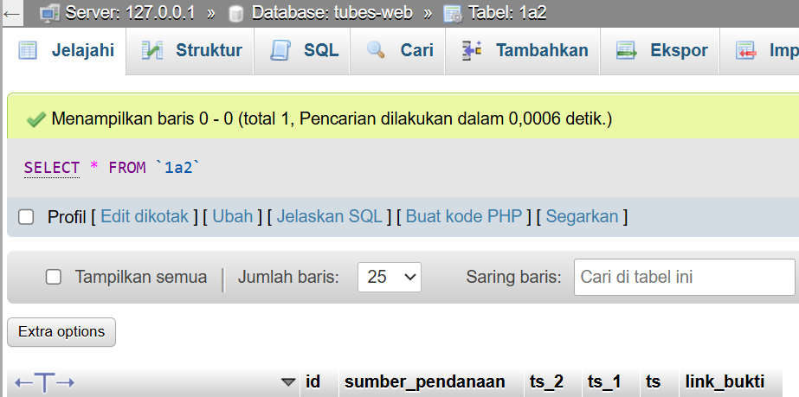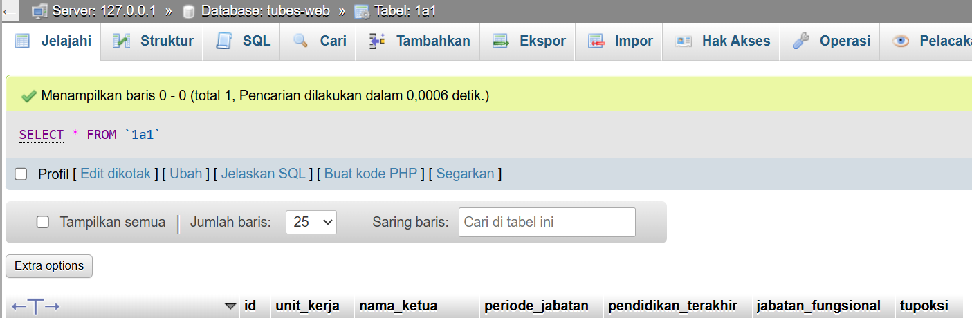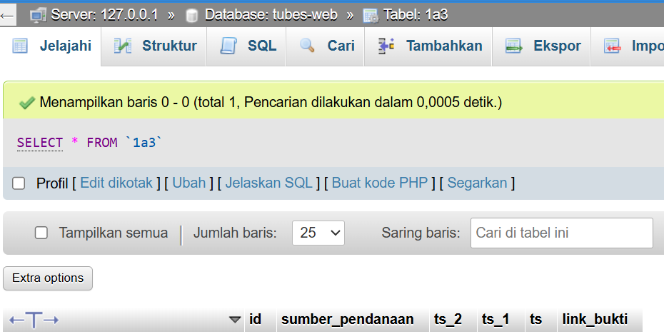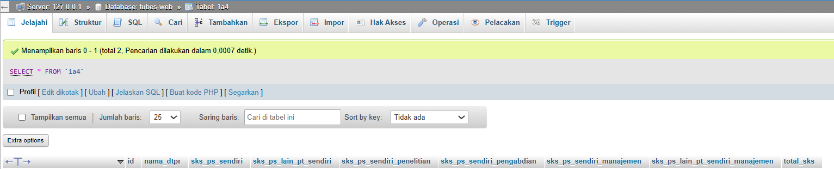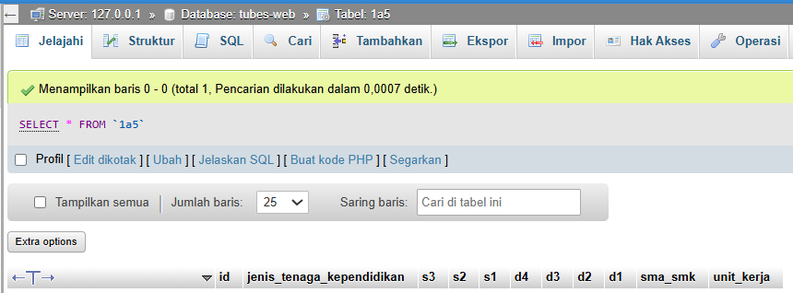
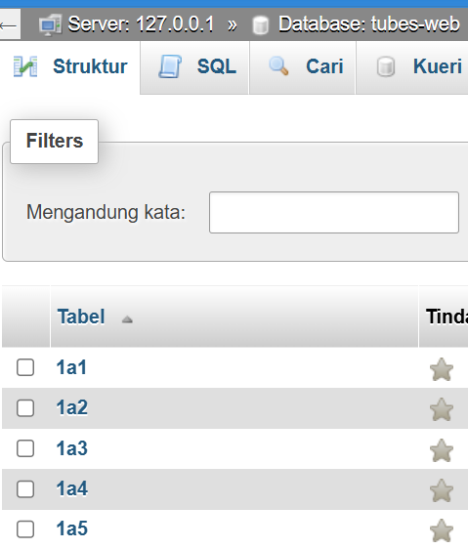

HASIL TAMPILAN
